Generative AI Explained

LINK TO VIDEOS: <https://drive.google.com/file/d/10COxQ6DAygUW5OZheAiUJxBpLv4eu6lx/view?usp=sharing>

**NVIDIA COURSE**

**Questions:**

**Generative AI Explained:**

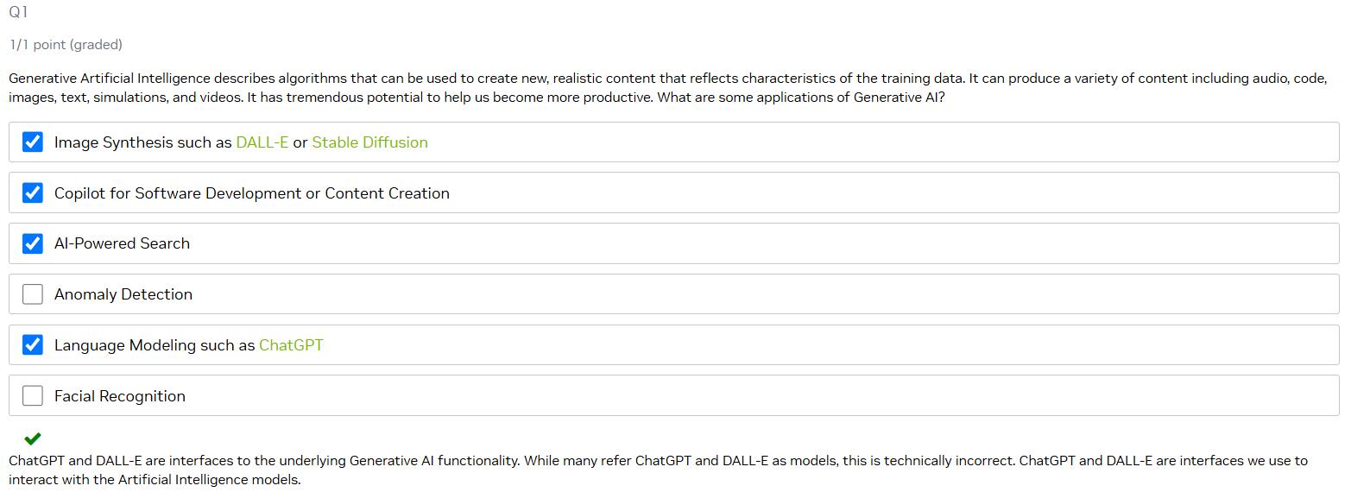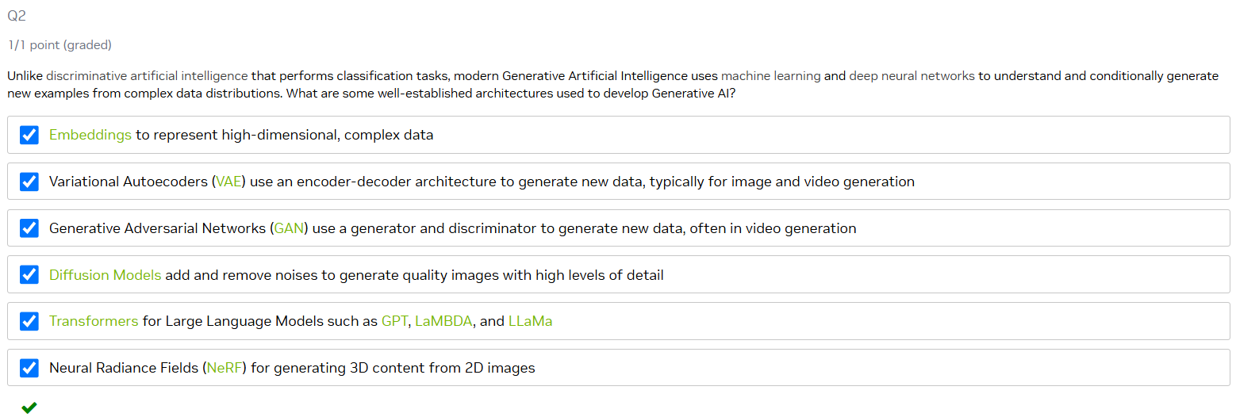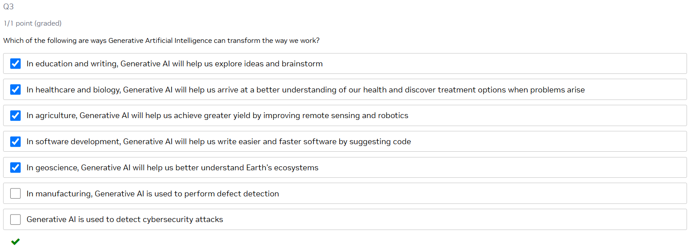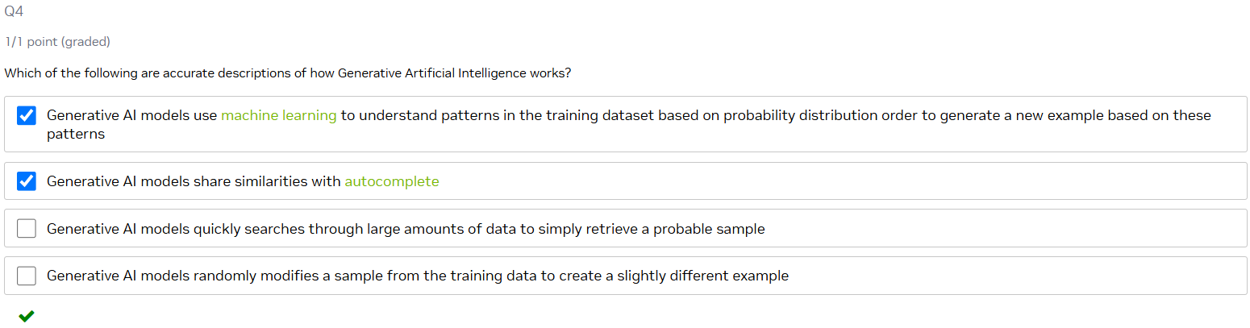

**Applications of Generative AI – Language**

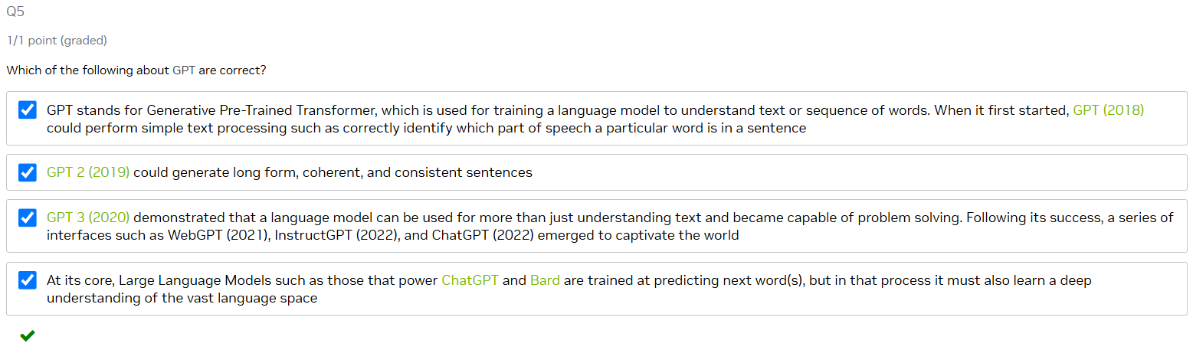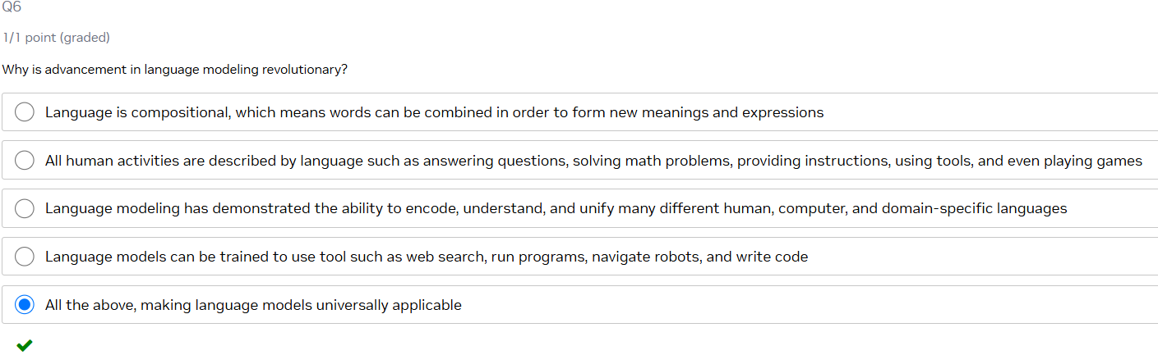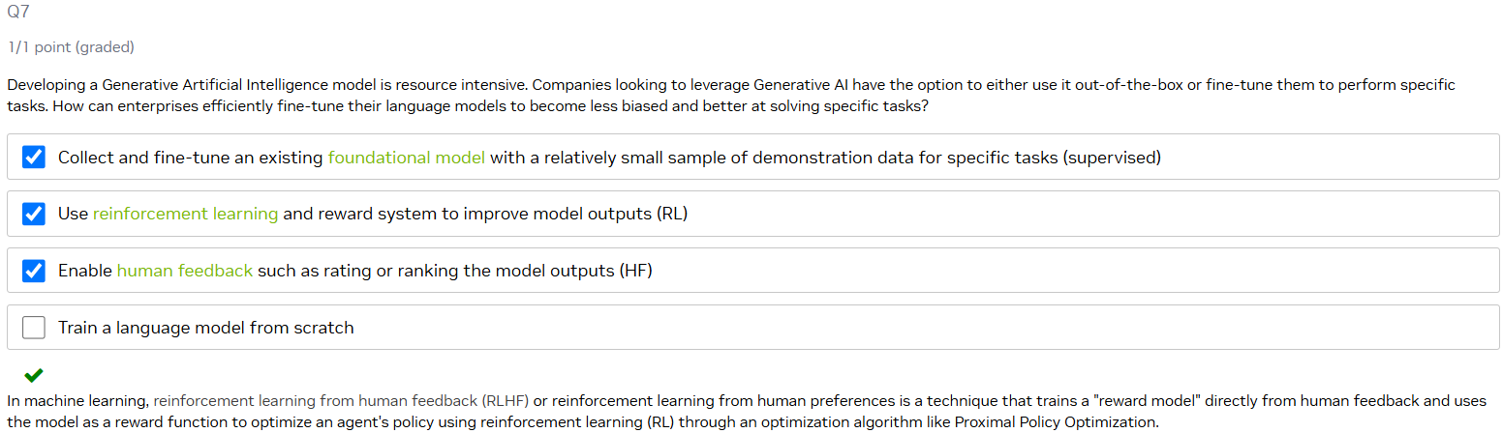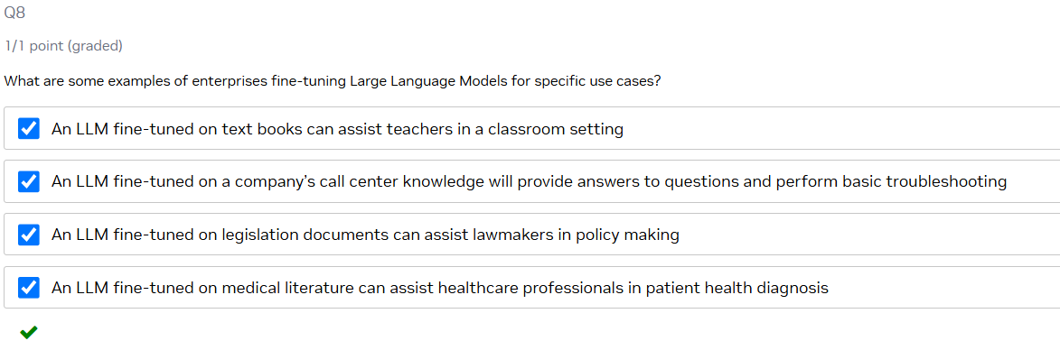

**Applications of Generative AI - Other Modalities**

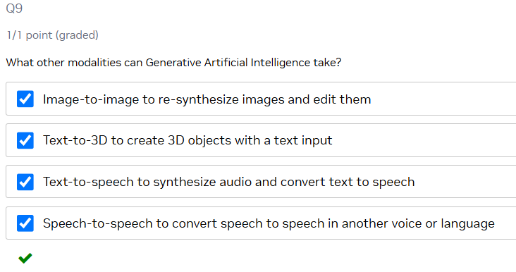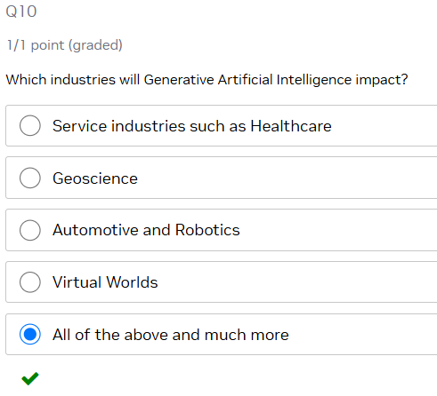

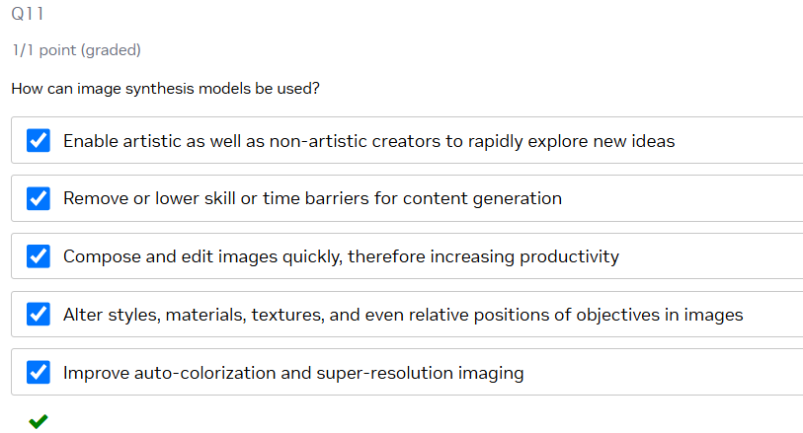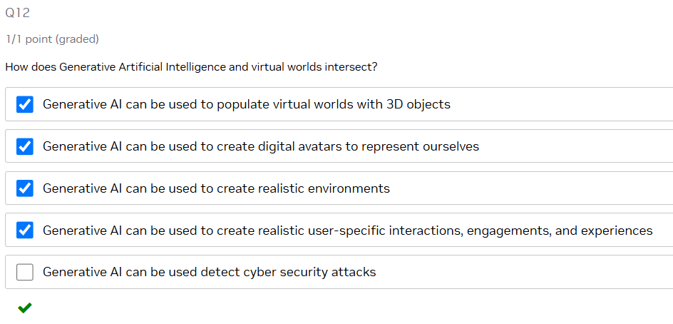

**Challenges and Opportunities of Generative AI**

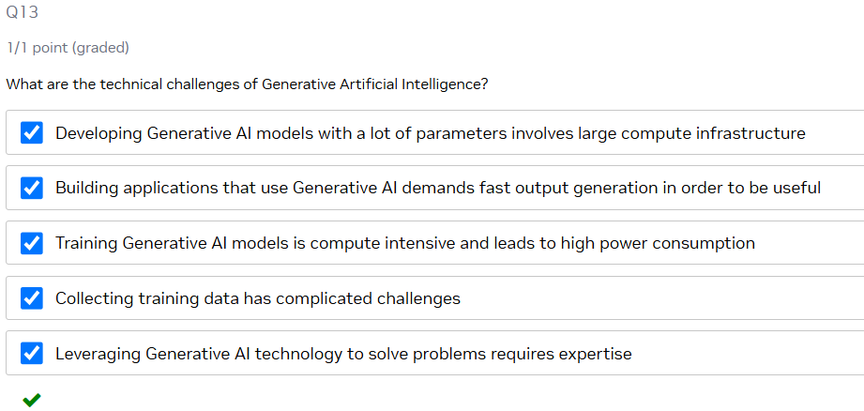

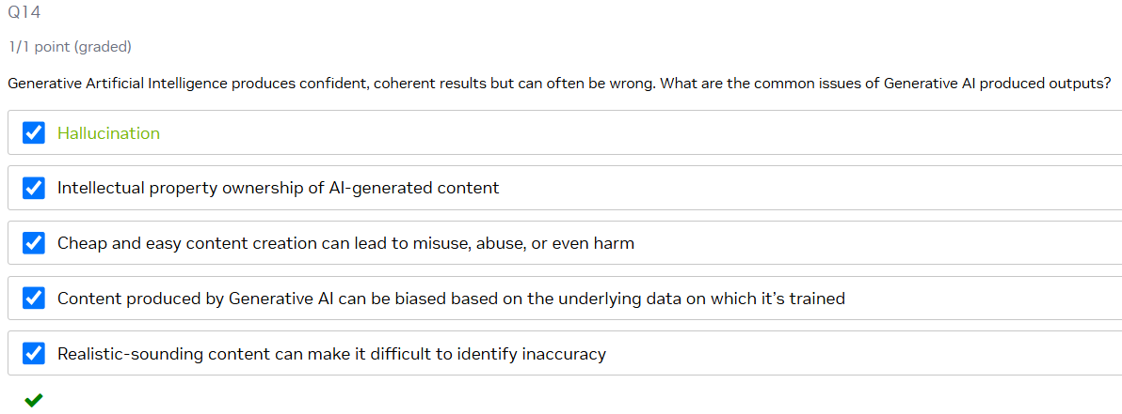

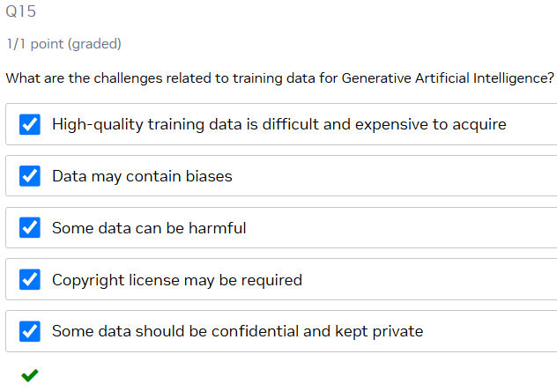

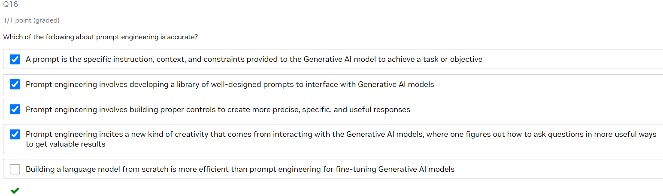

**Summary:**

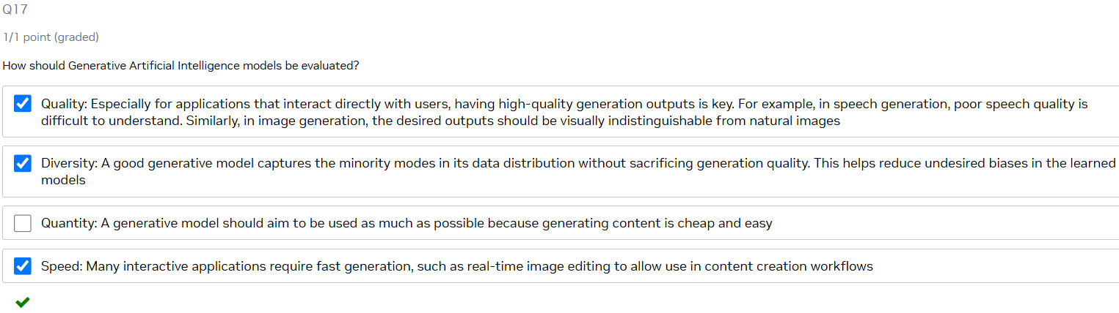

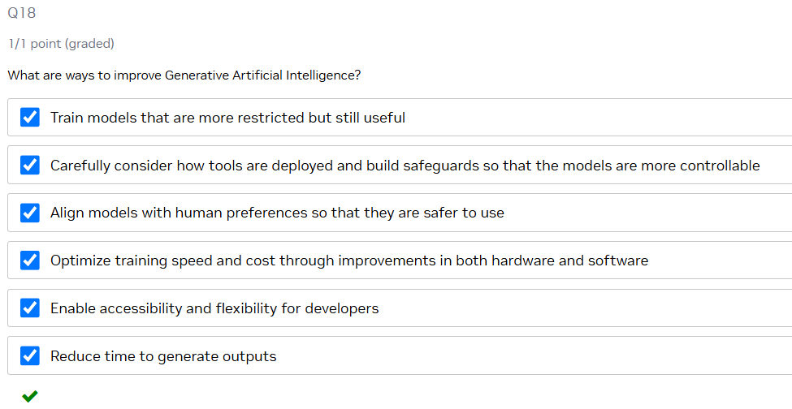

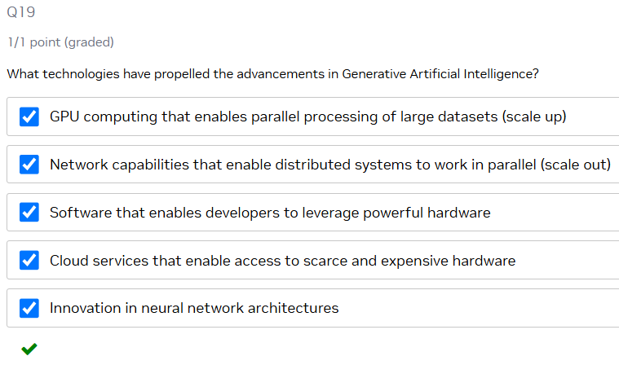

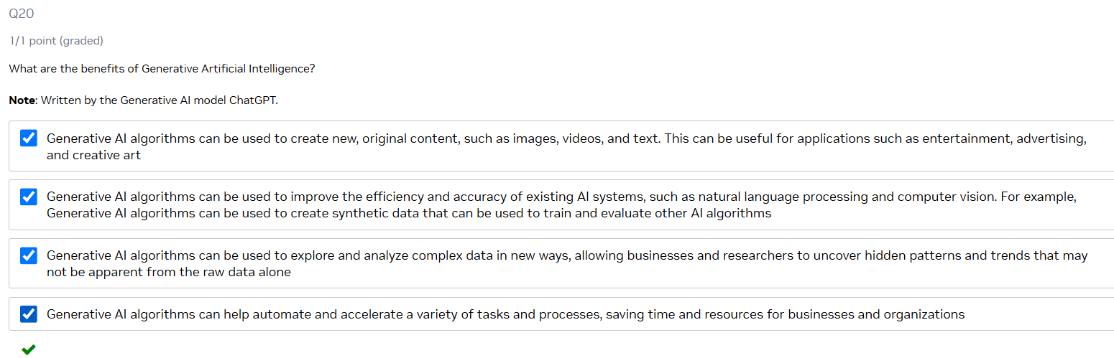

**Additional resources:**

1. [**What is Generative AI**](https://www.nvidia.com/en-us/glossary/data-science/generative-ai/)
2. [**What Runs ChatGPT**](https://www.youtube.com/watch?v=Rk3nTUfRZmo)
3. [**NVIDIA at SIGGRAPH**](https://www.nvidia.com/en-us/events/siggraph/)
4. [**RAG Explainer**](https://blogs.nvidia.com/blog/what-is-retrieval-augmented-generation/)
5. [**AI Chatbot with RAG Workflow**](https://www.nvidia.com/en-us/ai-data-science/ai-workflows/generative-ai-chatbots/)
6. [**RAG 101: Demystifying Retrieval-Augmented Generation Pipelines**](https://developer.nvidia.com/blog/rag-101-demystifying-retrieval-augmented-generation-pipelines/)
7. [**RAG 102: Deploying Retrieval-Augmented Generation Applications on NVIDIA GH200 Delivers Accelerated Performance**](https://developer.nvidia.com/blog/deploying-retrieval-augmented-generation-applications-on-nvidia-gh200-delivers-accelerated-performance/)
8. [**Getting Started Examples on GitHub**](https://github.com/NVIDIA/GenerativeAIExamples)[**RAG in 5 Minutes**](https://github.com/NVIDIA/GenerativeAIExamples/tree/main/community/5_mins_rag_no_gpu)

**AI for a Better World**

**NVIDIA was created to solve the world’s greatest challenges.**

AI for Good: [Unlocking the Potential of AI in Drug Discovery](https://web-assets.bcg.com/86/e5/19d29e2246c7935e179db8257dd5/unlocking-the-potential-of-ai-in-drug-discovery-vf.pdf)

Sustainability and Climate: [NVIDIA Announces Earth Climate Digital Twin](https://nvidianews.nvidia.com/news/nvidia-announces-earth-climate-digital-twin)

Economic Development:

[How Gen AI Can Shape the Future of Agriculture](https://www.mckinsey.com/industries/agriculture/our-insights/from-bytes-to-bushels-how-gen-ai-can-shape-the-future-of-agriculture)

[Enterprise Value From Digital Factories](https://www.mckinsey.com/capabilities/operations/our-insights/industrys-fast-mover-advantage-enterprise-value-from-digital-factories)